Taylor Larrechea

Dr. Gustafson

Math 365

March 27, 2018

**Planning a Backpacking Trip To Pikes Peak**

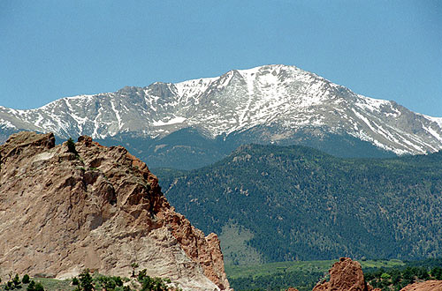

www.14ers.com

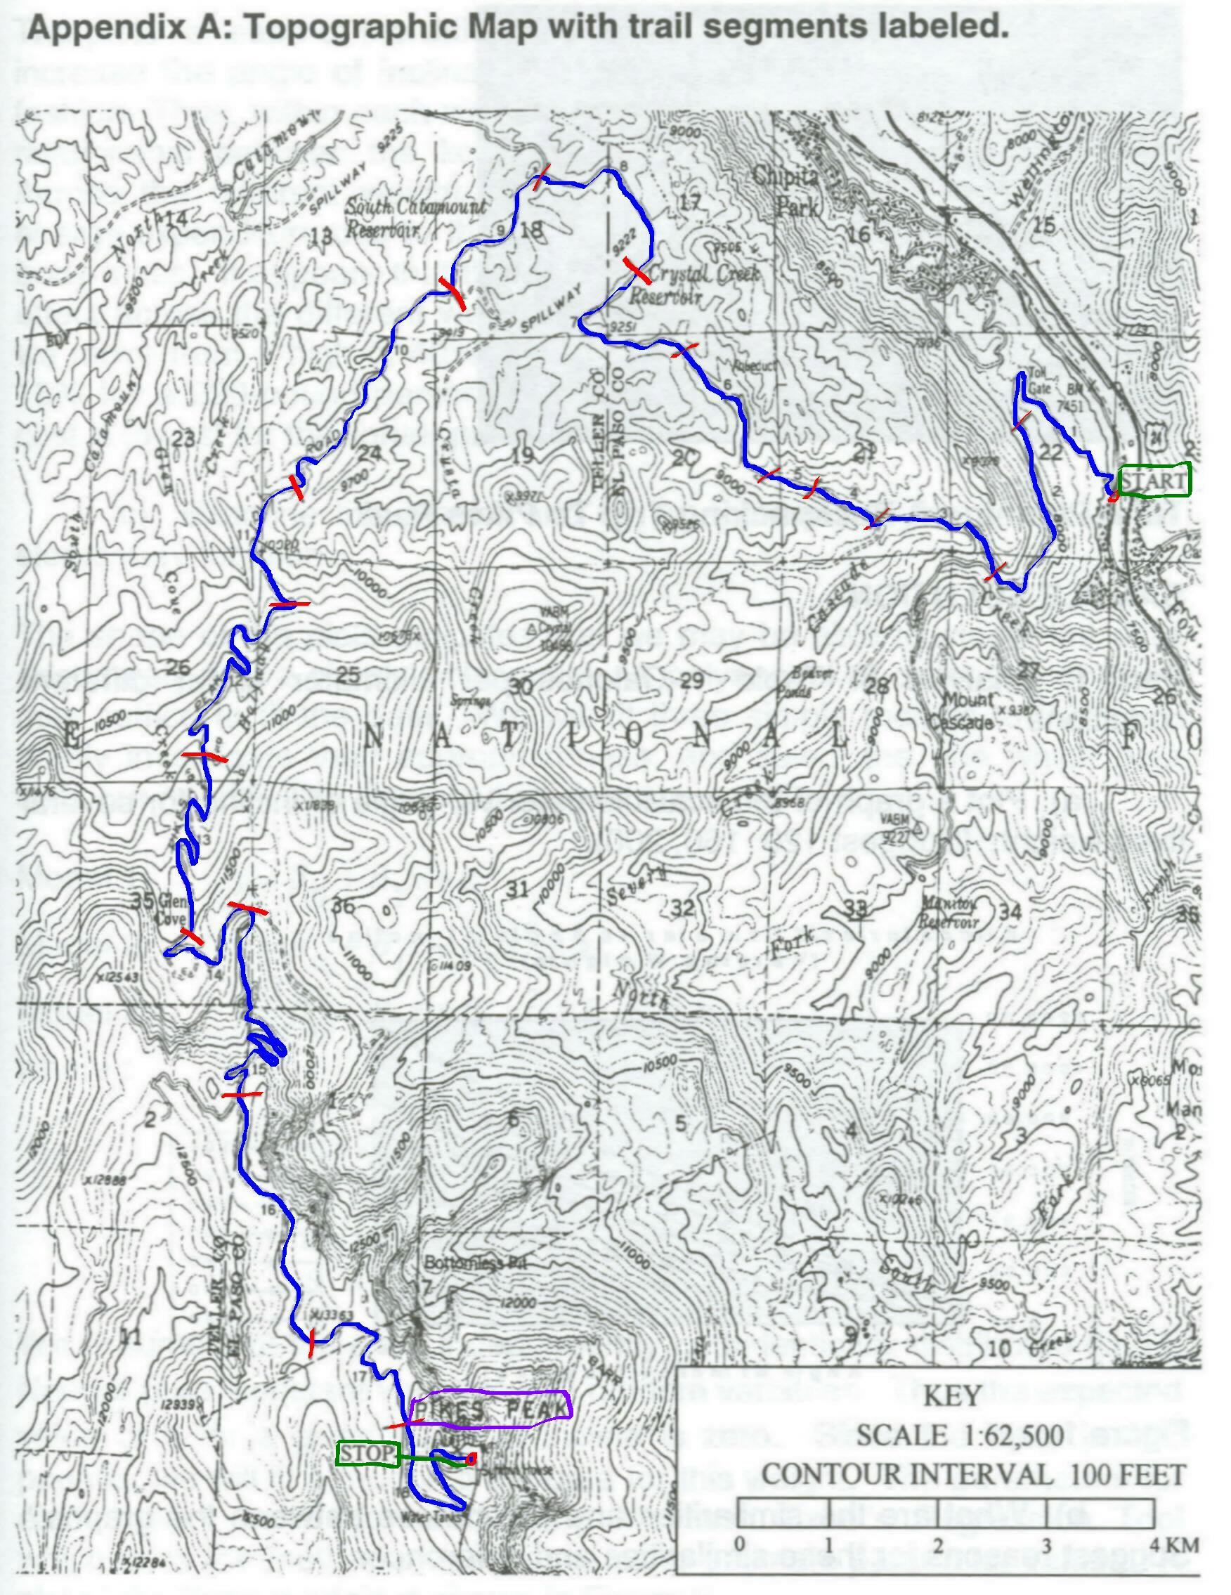

**Background**

At the summit of Pikes Peak, Katharine Lee Bates was inspired to pen the lines to her most famous poem, "America the Beautiful." The sights of vast open skies, planted fields, and the majestic Rocky Mountains overwhelmed her.

To enjoy such an experience, a hiker is planning a backpacking trip to the top of Pikes Peak. He has decided to hike along Pikes Peak Toll Road. He has obtained a topographical map of the showing the trail and each leg of the trip (see the bars drawn across road trail on the map). The start point is labeled on upper right part of the map. The stop point, the top of Pikes Peak is labeled at the bottom of the map. He has talked to a friend who is an exercise physiologist and found that he should exert a maximum of 3000 kcal/day in hiking. His friend has also provided some experimental results from a study of the energy cost of human locomotion (see Tables 1 and 2 below). The hiker has determined that he will need to carry a pack weighing 40 pounds containing his food and shelter for the trip. Additionally, he must complete the trip in 2 days. The hiker weighs 180 pounds.

The hiker needs to answer the following questions in order to complete planning for the trip:

1. Based upon the route indicated on the map, how many kilocalories (kcal) will he expend in reaching the top of Pikes Peak?How long will it take him to complete the trip?
   1. Assuming that he can expend a maximum of 3,000 kcal/day, where should he plan to make camp so that he does not exceed this limit? Can he make the trip in 2 days under this constraint?
   2. Suppose that he decides to hike at most 7 hours per day. Where should he plan to make camp based upon this constraint? Can he make the trip within 2 days under this constraint?
   3. If either of the two choices above is not possible, where are possible sites to camp and reach the mountain top within the constraints of kilocalories and hours hiked per day (i.e., relax the 2-day constraint)?

We will address these questions in this project.

****To get started, save this document as “Math 365 Project 4 Last Name First Name”. ***

You can then use this document as a template for completing the project. When finished, save as a PDF file and turn in to Dropbox.

**Data Tables**

According to the exercise physiologist, the data in Tables 1 and 2 were gathered assuming that subjects moved at a comfortable rate of movement and carried a standard load of 40 pounds. The term “comfortable” is defined as the speed at which the subjects could move and not exceed a heart rate of 100 beats per minute or an energy expenditure of about 5 kcals/min.

Table 1: Table of kilocalories/kilometer by different weights of subject and angles of inclination

|  |  |  |  |  |  |  |  |  |  |  |  |
| --- | --- | --- | --- | --- | --- | --- | --- | --- | --- | --- | --- |
|  | 0 | 3 | 6 | 9 | 12 | 15 | 18 | 21 | 24 | 27 | 30 |
| 100 lbs | 52.08 | 76.92 | 108.53 | 144.63 | 183.70 | 225.01 | 268.34 | 313.73 | 361.36 | 411.54 | 464.69 |
| 120 lbs | 56.78 | 86.69 | 125.06 | 168.72 | 215.73 | 265.26 | 317.09 | 371.28 | 428.09 | 487.91 | 551.22 |
| 140 lbs | 61.65 | 97.40 | 143.55 | 195.82 | 251.84 | 310.68 | 372.11 | 436.26 | 503.44 | 574.13 | 648.91 |
| 160 lbs | 66.74 | 109.18 | 164.27 | 226.37 | 292.61 | 361.98 | 434.29 | 509.68 | 588.59 | 671.57 | 759.31 |
| 180 lbs | 72.07 | 122.26 | 187.66 | 260.98 | 338.86 | 420.21 | 504.86 | 593.04 | 685.26 | 782.19 | 884.65 |
| 200 lbs | 77.73 | 136.90 | 214.25 | 300.48 | 391.69 | 486.74 | 585.50 | 688.30 | 795.74 | 908.62 | 1027.91 |
| 220 lbs | 83.77 | 153.48 | 244.78 | 345.95 | 452.56 | 563.41 | 678.45 | 798.09 | 923.08 | 1054.34 | 1193.02 |

Table 2: Table of kilometers/hour for a comfortable walk by different weights of subject and angles of inclination

|  |  |  |  |  |  |  |  |  |  |  |  |
| --- | --- | --- | --- | --- | --- | --- | --- | --- | --- | --- | --- |
|  | 0 | 3 | 6 | 9 | 12 | 15 | 18 | 21 | 24 | 27 | 30 |
| 100 lbs | 5.50 | 3.73 | 2.64 | 1.98 | 1.56 | 1.27 | 1.07 | 0.91 | 0.79 | 0.70 | 0.62 |
| 120 lbs | 5.05 | 3.31 | 2.29 | 1.70 | 1.33 | 1.08 | 0.90 | 0.77 | 0.67 | 0.59 | 0.52 |
| 140 lbs | 4.65 | 2.94 | 2.00 | 1.46 | 1.14 | 0.92 | 0.77 | 0.66 | 0.57 | 0.50 | 0.44 |
| 160 lbs | 4.30 | 2.63 | 1.75 | 1.27 | 0.98 | 0.79 | 0.66 | 0.56 | 0.49 | 0.43 | 0.38 |
| 180 lbs | 3.98 | 2.34 | 1.53 | 1.10 | 0.85 | 0.68 | 0.57 | 0.48 | 0.42 | 0.37 | 0.32 |
| 200 lbs | 3.69 | 2.09 | 1.34 | 0.95 | 0.73 | 0.59 | 0.49 | 0.42 | 0.36 | 0.32 | 0.28 |
| 220 lbs | 3.42 | 1.87 | 1.17 | 0.83 | 0.63 | 0.51 | 0.42 | 0.36 | 0.31 | 0.27 | 0.24 |

**Part 1: Analysis of Table 1: Calories per kilometer under different conditions.**

1. Plot a graph of the kcal/kilometer vs. angle of incline for several fixed weights. (Use 120,160, 180 lbs).

b) What are the similarities and differences between the graphs? Briefly describe and discuss.

All of the different weights seem to grow very close to the same rate as one another when the angle of inclination is raised. It turns out that all of these graphs fit to a polynomial curve of the second order. The differences are that the greater values of weight (160 lbs and 180 lbs) expend more Kilo Calories/ Kilometer at larger angles of inclination. This intuitively makes sense since a larger person is going to need more energy and thus burns more energy compared to a smaller person.

c) Examine the graphs and try to approximate the data with an elementary function. Use Excel’s trend line option with either a second or third-degree polynomial, whichever is “best” (justify your choice). Be sure to display the equation of the polynomial you fit to each data set, as you will need these later (the equation for the 180 lb hiker in particular).

Firs things first the equations for the models at various weights are:

120 lb Model: $y=0.1718x^{2}+11.491x+52.963$

160 lb Model: $y=0.2259x^{2}+16.538x+61.198$

180 lb Model: $y=0.257x^{2}+19.639x+65.544$

The second order polynomial was used because the $R^{2}$ values that were found with the aide of excel all had high values when a trend line was fitted to the data. The $R^{2}$ value all three models were 0.9999 which means these trend lines did a good job at modeling the data.

Part 2: Analysis of Table 2: Kilometers per hour under different conditions.

1. Plot a graph of the kilometers/hr vs. inclination for several fixed weights (use 120,160, 180 lbs).

b) What are the similarities and differences between the graphs? Briefly describe and discuss.

All of these graphs fit the curve of polynomial to the third degree. The heavier weights (160 lb and 180 lb) tend to run less kilometers per hour compared to 120 lb’s when the angle of inclination is increased. As the angle reaches it’s maximum, all three weight classes get really close to one another in the number of kilometers per hour that they can walk. At the beginning there is more of a difference and this makes sense due to the body masses and the amount of energy required to start moving.

c) Examine the graphs and try to approximate the data with an elementary function. Use Excel’s trend line option with either a second or third-degree polynomial, whichever is “best” (justify your choice). Be sure to display the equation of the polynomial you fit to each data set, as you will need these later (the equation for the 180 lb hiker in particular).

120 lb Model: $y=-0.0004x^{3}+0.0259x^{2}-0.5591x+4.9191$

160 lb Model: $y=-0.0004x^{3}+0.0249x^{2}-0.5144x+4.148$

180 lb Model: $y=-0.0004x^{3}+0.0244x^{2}-0.04924x+3.8166$

The third-degree polynomials fit the data the best due to the $R^{2}$ values being the greatest at this degree. Since the $R^{2}$ value determines how well the equation fits the original data, this is why the $R^{2}$ was used to validate the choice of power for the polynomial. The $R^{2}$ for the 120 lb model was 0.9949 where the 160 lb and 180 lb model’s $R^{2}$ values were 0.9911 and 0.9884 respectively. These values are why the third degree was used to model this relationship.

Part 3: Analysis of the topographical map.

a) Use the elevation data given below and in the Excel spreadsheet (or alternatively, use the topographical map) to construct a graph of the elevation vs. the distance traveled on the trail. Use straight lines to connect the points of the trail segments on the route.

|  |  |  |  |
| --- | --- | --- | --- |
| **Toll Road Route** | |  |  |
| **Cumulative Distance (km)** | **Elevation (m)** | **Cumulative Distance (miles)** | **Elevation (ft)** |
| 0 | 2250 | 0.0 | 7382 |
| 1 | 2303 | 0.6 | 7556 |
| 2 | 2378 | 1.2 | 7802 |
| 3 | 2474 | 1.9 | 8117 |
| 4 | 2585 | 2.5 | 8481 |
| 5 | 2676 | 3.1 | 8780 |
| 6 | 2656 | 3.7 | 8714 |
| 7 | 2754 | 4.3 | 9035 |
| 8 | 2802 | 5.0 | 9193 |
| 9 | 2833 | 5.6 | 9295 |
| 10 | 2812 | 6.2 | 9226 |
| 11 | 2860 | 6.8 | 9383 |
| 12 | 2869 | 7.5 | 9413 |
| 13 | 2888 | 8.1 | 9475 |
| 14 | 2924 | 8.7 | 9593 |
| 15 | 3006 | 9.3 | 9862 |
| 16 | 3125 | 9.9 | 10253 |
| 17 | 3214 | 10.6 | 10545 |
| 18 | 3308 | 11.2 | 10853 |
| 19 | 3399 | 11.8 | 11152 |
| 20 | 3498 | 12.4 | 11476 |
| 21 | 3581 | 13.0 | 11749 |
| 22 | 3692 | 13.7 | 12113 |
| 23 | 3788 | 14.3 | 12428 |
| 24 | 3864 | 14.9 | 12677 |
| 25 | 3951 | 15.5 | 12963 |
| 26 | 3955 | 16.2 | 12976 |
| 27 | 3994 | 16.8 | 13104 |
| 28 | 4050 | 17.4 | 13287 |
| 29 | 4145 | 18.0 | 13599 |
| 30 | 4230 | 18.6 | 13878 |
| 31 | 4297 | 19.3 | 14098 |

b) Note the changes in slope at each of the trail segments. What do these slopes represent in terms that the hiker will appreciate? Do they provide approximations to the angle of incline? Do these slopes give an instantaneous rate of change or an average rate of change over the trail segment? What advantages would there be to collecting more trail segment data points?

The steeper the slope the greater the incline that the hiker has to hike. This means at parts where the line in the graphs level out the hiker will not be changing elevation much and will be close to walking on flat ground. They would appreciate this because it would allow some time for less intensive walking at least for a little bit. These slopes provide approximations for the the angle of incline because the steeper the slope the greater the incline, so the hiker may appreciate this to better plan out their hike. The individual segments give an average rate of change over the intervals of which we can observe them. The one advantage of collecting more data points is that it would allow for more accurate plots and thus a better representation of the trail itself.

Part 4: Construct a table (see below) to tabulate the results of the analysis of the graphs done in Requirements 1, 2, and 3, for a 180 lb hiker.

See below. Note that all distances need to be converted to km, for which the energy expended and time data is then computed by using the polynomial fitted previously (show polynomial used) to the corresponding data. The incline data (degrees) is computed by using the following steps: (1) use arctangent function (show sample calculation) on slopes to get angle measurement (in radians), and (2) convert these to degrees, using the conversion factor (180º) / (π radians).

**Sample Calculation**

Segment 4: Elevation Change / Distance Change = (0.053 km) / (1 km)

Elevation Change / Distance Change = 0.053

Arctan(0.053) $≈$ 6 $°$

The table of data can be seen on the next page.

**Table 3: Results of analysis of topographic map (for a 180 lb hiker).**

|  |  |  |  |  |  |  |  |
| --- | --- | --- | --- | --- | --- | --- | --- |
| **Segment** | **Distance (km)** | **Cumulative Distance (km)** | **Elevation Change (km)** | **Elevation Change / Distance Change** | **Incline (Degrees)** | **Energy Expended (kcal)** | **Time (hours)** |
| 0 | 0 | 0 | 0 | 0 | 0 | 0 | 0 |
| 1 | 1 | 1 | 0.053 | 0.053 | 3 | 127 | 0.39 |
| 2 | 1 | 2 | 0.075 | 0.075 | 4 | 155 | 0.47 |
| 3 | 1 | 3 | 0.096 | 0.096 | 5 | 181 | 0.56 |
| 4 | 1 | 4 | 0.111 | 0.111 | 6 | 200 | 0.64 |
| 5 | 1 | 5 | 0.091 | 0.091 | 5 | 175 | 0.54 |
| 6 | 1 | 6 | -0.020 | -0.020 | -1 | 43 | 0.23 |
| 7 | 1 | 7 | 0.098 | 0.098 | 6 | 184 | 0.57 |
| 8 | 1 | 8 | 0.048 | 0.048 | 3 | 121 | 0.38 |
| 9 | 1 | 9 | 0.031 | 0.031 | 2 | 101 | 0.33 |
| 10 | 1 | 10 | -0.021 | -0.021 | -1 | 42 | 0.23 |
| 11 | 1 | 11 | 0.048 | 0.048 | 3 | 121 | 0.38 |
| 12 | 1 | 12 | 0.009 | 0.009 | 1 | 76 | 0.28 |
| 13 | 1 | 13 | 0.019 | 0.019 | 1 | 87 | 0.30 |
| 14 | 1 | 14 | 0.036 | 0.036 | 2 | 107 | 0.34 |
| 15 | 1 | 15 | 0.082 | 0.082 | 5 | 163 | 0.50 |
| 16 | 1 | 16 | 0.119 | 0.119 | 7 | 211 | 0.69 |
| 17 | 1 | 17 | 0.089 | 0.089 | 5 | 172 | 0.53 |
| 18 | 1 | 18 | 0.094 | 0.094 | 5 | 178 | 0.55 |
| 19 | 1 | 19 | 0.091 | 0.091 | 5 | 175 | 0.54 |
| 20 | 1 | 20 | 0.099 | 0.099 | 6 | 185 | 0.58 |
| 21 | 1 | 21 | 0.083 | 0.083 | 5 | 165 | 0.51 |
| 22 | 1 | 22 | 0.111 | 0.111 | 6 | 200 | 0.64 |
| 23 | 1 | 23 | 0.096 | 0.096 | 5 | 181 | 0.56 |
| 24 | 1 | 24 | 0.076 | 0.076 | 4 | 156 | 0.48 |
| 25 | 1 | 25 | 0.087 | 0.087 | 5 | 170 | 0.52 |
| 26 | 1 | 26 | 0.004 | 0.004 | 0 | 70 | 0.27 |
| 27 | 1 | 27 | 0.039 | 0.039 | 2 | 111 | 0.35 |
| 28 | 1 | 28 | 0.056 | 0.056 | 3 | 131 | 0.40 |
| 29 | 1 | 29 | 0.095 | 0.095 | 5 | 180 | 0.56 |
| 30 | 1 | 30 | 0.085 | 0.085 | 5 | 167 | 0.51 |
| 31 | 1 | 31 | 0.067 | 0.067 | 4 | 145 | 0.44 |
| **Sum** | **31** |  | **2.047** |  |  | **4479** | **14.31** |

The equations used for the Energy Expended and the Time in Hours were,

$$y_{1}=0.257x^{2}+19.639x+65.544$$

$$y_{2}=-0.0004x^{3}+0.0244x^{2}-0.04924x+3.8166$$

Energy Expended: ( $y_{1})$ $∙$ distance traveled in (km).

Time: ${\left(y_{2}\right)}^{-1}∙$ distance traveled in (km).

The *x* variable in both equations above are the incline of the hike that the walkers are experiencing. The $y_{1}$ variable in the energy expended equation and is the kilo calories per kilometer burned in this hike and that is why it is multiplied by distance traveled so that the kilo calories burned can remain. The $y_{2}$ variable in the time equation is the distance traveled per hour that the hiker is experiencing. Once this is inverted, it is multiplied by the distance traveled so that we can have the time in hours that this hike took.

**Part 5:**

Data for table 5 can be seen on the next page.

**Table 4: Summary of Data for 180 lb Hiker**

|  |  |  |  |
| --- | --- | --- | --- |
| **Segment** | **Running Energy Expended (kcals)** | **Running Time (hrs)** | **Elevation (ft)** |
| 0 | 0 | 0.00 | 7382 |
| 1 | 127 | 0.39 | 7556 |
| 2 | 282 | 0.87 | 7802 |
| 3 | 463 | 1.43 | 8117 |
| 4 | 663 | 2.07 | 8481 |
| 5 | 838 | 2.61 | 8780 |
| 6 | 881 | 2.84 | 8714 |
| 7 | 1065 | 3.41 | 9035 |
| 8 | 1186 | 3.79 | 9193 |
| 9 | 1287 | 4.13 | 9295 |
| 10 | 1330 | 4.35 | 9226 |
| 11 | 1451 | 4.73 | 9383 |
| 12 | 1527 | 5.01 | 9413 |
| 13 | 1614 | 5.31 | 9475 |
| 14 | 1721 | 5.66 | 9593 |
| 15 | 1884 | 6.16 | 9862 |
| 16 | 2095 | 6.85 | 10253 |
| 17 | 2267 | 7.38 | 10545 |
| 18 | 2446 | 7.93 | 10853 |
| 19 | 2620 | 8.47 | 11152 |
| 20 | 2805 | 9.05 | 11476 |
| 21 | 2970 | 9.56 | 11749 |
| 22 | 3170 | 10.20 | 12113 |
| 23 | 3351 | 10.76 | 12428 |
| 24 | 3507 | 11.24 | 12677 |
| 25 | 3676 | 11.76 | 12963 |
| 26 | 3746 | 12.03 | 12976 |
| 27 | 3857 | 12.39 | 13104 |
| 28 | 3988 | 12.79 | 13287 |
| 29 | 4168 | 13.35 | 13599 |
| 30 | 4335 | 13.86 | 13878 |
| 31 | 4479 | 14.31 | 14098 |

a) Based upon the route indicated on the topographical map, how many kilocalories (kcals) will he expend in reaching the top of Pikes Peak? How long will it take him to complete the trip?

The hiker will expend 4479 (kcals) and it will take 14.31 hours to complete the trip.

b) Assuming that he can expend a maximum of 3,000 kcals/day, where should he plan to make camp so that he does not exceed this limit? Can he make the trip in 2 days under this constraint?

Just after segment 22 3,000 (kcals) are expended by the hiker for the model of 180 lb hiker which can be seen in the above table. At this segment the elevation is at 12,113 feet. So, a reasonable spot for the hiker to stop and rest off of this 3,000 (kals) maximum would be Glens Cove. This trip can be made under 2 days time if the hiker hikes on the constraint of a maximum 3,000 (kals/day) considering from segment 22 to segment 31, the hiker only expends about another 1400 (kcals). This means the hiker will expend about half his maximum energy in the second trip.

c) Suppose that he decides to hike at most 7 hours per day. Where should he plan to make camp based upon this constraint? Can he make the trip within 2 days under this constraint?

If the hiker hikes only 7 hours per day, after the first day he will make it to about 10,300 feet in elevation. This occurs a little bit after segment 16 seen in the above table. In respect to the topographical map this is just before the halfway mark indicated on the map. If the hiker wishes to hike with this constraint he should stop a little bit before the peak that is right next to the halfway mark. Regardless of where the hiker decides to stop with this constraint, he cannot complete the entire trip in two days with this constraint. So, the 3,000 (kcals/day) is a lot better way of determining how long he can hiker in one day to be able to make the trip in under two days.

d) If either of the two choices above is not possible, where are possible sites to camp and reach the mountain top within the constraints of kilocalories and hours hiked per day (i.e., relax the 2-day constraint)?

Since the only constraint that is going to let the hiker get to the top in under two days he should plan to camp around Glen’s Cove when he expends his maximum 3,000 (kcals) in one day. The total trip takes about 14 hours and 20 minutes, so if the hiker were to hike on the 7 hours per day constraint, he would still have about 20 minutes left to hike. Thus meaning that the constraint of 7 hours per day for hiking is inadequate for the request of under two days.

Part 6:

What additional factors could be considered to make the model more realistic? How would these factors affect the results predicted above?

Other factors for this model should include times for breaks in between. It is very unrealistic to have someone hike 7 hours strait on a trail like the one that is looked at in this model. By doing this it would affect the total time that it would take for the trip to happen thus changing how long the hiker may have to hike in each day. The breaks offer the benefit of conserving some energy for a little bit, so the hiker may possibly be able to hike for longer and thus farther in one day. This could even out the difference in time’s, but it more than likely would be favored by the hiker regardless! During these breaks the model can possibly incorporate calorie intake from possible snacks that the hiker may eat on his breaks at the indicated positions. This would then decrease the calorie intake because the hiker ate and thus allow for more hiking in one day. These two factors for me are the most prominent because they are realistic when hiking. So, in short I think the model should incorporate time for breaks from the hiker where they are supposed to eat a certain amount of food in (kcals) at these breaks.